Gentlemen, if you give me Liberty, you give me death…

The Courts and the States: Legislative Districting and Re-apportionment

Definitions:
- Apportionment
- How the number of seat are distributed
- Apportioned based on population means taking the total population and dividing it by the number of seats. This sets the population per district.
- Re- apportionment
- Re-calculating apportionment because of changes in population demographics; redistributing populations into districts
- Districting
- Drawing lines on a map to delineate the boundaries of each district
- Decennial census
- Every ten years, as required by the US constitution

Two potential areas for mischief:
- 1) Mal-apportionment
- Rottenboroughs
- Unequally distributed representation
- Population shifts

- Bad Boys, Bad Boys…
- 2) Gerrymander – Governor Eldridge Gerry’s Salamander shaped district
- Drawing district lines for partisan purposes

- Packing and Cracking
- Packing – putting lots of their people in one district
- Cracking – separating out the opposition so they can’t win
- Two Important Philosophical Questions:
Virtual or direct representation?
- Delegate or Statesman
Do we really believe in bicameralism?
- Remember the cup and the saucer?
- Two Important Constitutional Guarantees
- Equal protection under the 14th amendment
- Section. 1. All persons born or naturalized in the United States and subject to the jurisdiction thereof, are citizens of the United States and of the State wherein they reside. No State shall make or enforce any law which shall abridge the privileges or immunities of citizens of the United States; nor shall any State deprive any person of life, liberty, or property, without due process of law; nor deny to any person within its jurisdiction the equal protection of the laws.
- Section. 2. Representatives shall be apportioned among the several States according to their respective numbers, counting the whole number of persons in each State, excluding Indians not taxed. But when the right to vote at any election for the choice of electors for President and Vice President of the United States, Representatives in Congress, the Executive and Judicial officers of a State, or the members of the Legislature thereof, is denied to any of the male inhabitants of such State, being twenty-one years of age, and citizens of the United States, or in any way abridged, except for participation in rebellion, or other crime, the basis of representation therein shall be reduced in the proportion which the number of such male citizens shall bear to the whole number of male citizens twenty-one years of age in such State.
- Guarantee Clause – republican form of government

- Article Four:
- Section 4.
- The United States shall guarantee to every State in this Union a Republican Form of Government, and shall protect each of them against Invasion; and on Application of the Legislature, or of the Executive (when the Legislature cannot be convened) against domestic Violence.

- How bad was it?
- Florida
- What do Dr. John Gorrie and pesticides have to do with all this?
- 50,000 in Jefferson County, 500,000 in Dade
- 2 of 38 Senators were Republican
- Tennessee
- not since 1901
- Majority elected by 11% of population
- Connecticut
- Vermont
- Not since 1793!
- Majority of House elected by 11.9% of population
- One district had 24, while another had 35,531
- California
- Majority elected by 10.7% of population

- NOT going into the political thicket
- Colgrove v. Green – 1946
- A political question
- GOING into the thicket…
- Baker v. Carr – 1962
- A judiciable issue
- Tennessee House re-apportionment (none since re-construction)

- Reynolds v. Sims – 1964
- The Death of Bi-cameralism
- Alabama Senate
- People, not trees…
- One man, one vote
- The end of classical bi-cameral apportionment for the states

- Me Too! Me Too! Me Too!
- Westbury v. Saunders – 1964
- Congressional districts too, not just states

- The Voting Rights Act of 1969
- Re-authorized in 2006

- Challenges to the dilution of minority votes
- Do you pick your Representative or do they pick you?
- Shaw v. Reno – 1993
- Gerrymandering is not OK if race is the SOLE factor in drawing a district's lines

- VIETH et al. v. JUBELIRER, PRESIDENT OF THE PENNSYLVANIA SENATE, et al. - 2004
- Political gerrymandering is OK

- Welcome to the briar patch…
- Colorado’s ‘bi-partisan’ Commission
- Um, we really need to get this together before the primary… (Pennsylvania)
- I want to be a Part of it, in old New York …

- Well, what is it SUPPOSED to look like?
- http://www.arkansasredistricting.org/aboutTheProcess/Pages/RedistrictingCriteria.aspx

- Arkansas maps
- http://www.state.ar.us/arkdistrict/webhouse.pdf

- Arkansas’ System:
- Board of Apportionment Does State:
- Governor, Secretary of State, Attorney General
- General Assembly Does US House

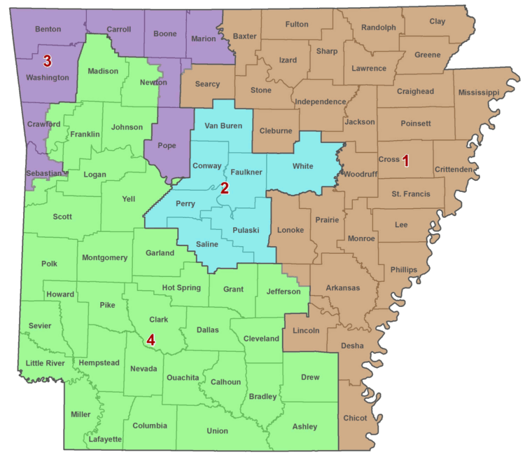
- GOD BLESS TEXAS…
- Stranger than fiction…
- 2003 Run, baby, run – Democrats decamp to Oklahoma
- 2005 Delay is indicted
- 2006 The Supremes get involved
- 6 different opinions!
- Mid-decade reapportionment is OK
- Racial gerrymandering vote dilution is NOT OK under the Voting Rights Act
- August of 2006
- The U.S. District Court for the Eastern District of Texas issues the final map for District 23

- LEAGUE OF UNITED LATIN AMERICAN CITIZENS V. PERRY 05-254)
- TRAVIS CTY., TX V. PERRY 05-276)
- JACKSON V. PERRY 05-439)
- GI FORUM V. PERRY
- (Consolidated – 2 hrs. for argument March 1, 2006!)
- Night-night, Justice Ginsberg…

- This time: http://gis1.tlc.state.tx.us/

- The Incumbent Protection Act?
- http://www.libertycountyflorida.com/
- http://www.flsenate.gov/Legislators/index.cfm?Mode=District%20Information&Submenu=2&Tab=legislators&CFID=69047298&CFTOKEN=80932020
- I am so ashamed…

- You ought to give Iowa a try!
- P 172
- Legislative Services Bureau
- Does NOT use party affiliation or voter addresses!
- Does NOT protect incumbents.
- House: https://www.legis.iowa.gov/DOCS/Resources/Redist/2011/2011-03-31/HouseStatewide8x11_color.pdf
- Senate: https://www.legis.iowa.gov/DOCS/Resources/Redist/2011/2011-03-31/SenateStatewide8x11_color.pdf
- Congress: A Thing of Beauty! https://www.legis.iowa.gov/DOCS/Resources/Redist/2011/2011-03-31/CongressStatewide8x11_color.pdf
- But Arizona, not so much…

